BaseBot introduction

BaseBot is a very simple machine learning program that was inspired by a YouTube video created by Mark Rober called Stealing Baseball Signs published in June of 2019. In that video Mark enlists another youtuber who goes by the name Jabril to write write two applications to that can record the signals given to runners on base and predict when a runner will steal a base and when the runner will stay. After watching this video in 2021 I had recently written a simple application that created decision trees and made decisions based of said tree. I realized that I could write a similar piece of decision tree based machine learning software without the use of third party libraries like SciLearn, PyTorch, or other similar packages. In this document I will describe how to use BaseBot and what kind of questions it can be applied to in order to get a useful answer.

Like I said earlier, this application was inspired by Jabril’s baseball signal application and is designed largely to do answer the same kind of questions as his application. I would recommend you watch Mark Rober’s video mentioned above to get a basic idea. Basebot is designed answer simple yes no questions based on the sequence of events in a single data point base previous data points it has been given. To give you an idea of how this works I lets walk through teaching this program how to identify when a base runner is about to steal base.

After opening the application you will want to map events that can happen in a single sequence that makes a single datapoint. Below you will notice a series of lowercase letters labeled with “empty description”
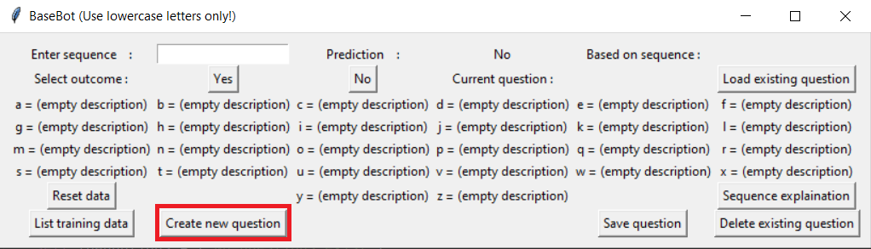
to change this we click the highlighted “Create new question”. After we click this button we will be shown a new dialog:
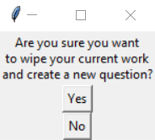

We have no data yet so we are just going to click “Yes” and that will bring up the following dialog:
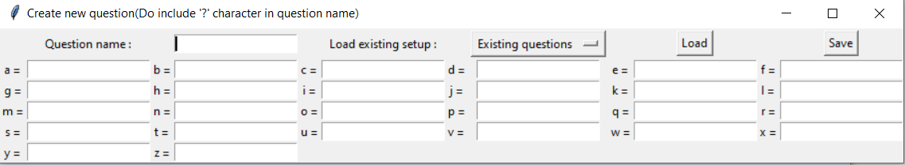
Next we name the question that we are asking we name it “Steal base” and assign all individual events that could result in a ‘yes’ to the question to a letter like so:
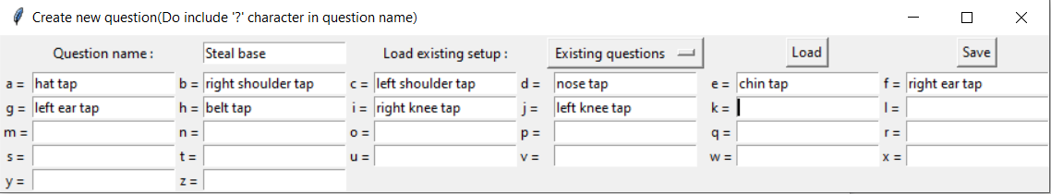
Next we click the ‘Save’ button and then click yes on the following dialog:
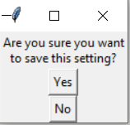

Then the main dialog should look something like this:
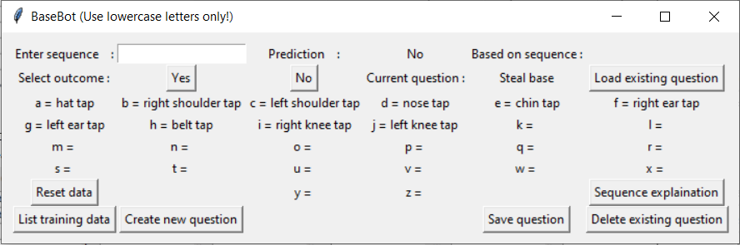
Our first sequence will be:

‘hat tap’, ‘belt tap’, ‘nose tap’, ‘belt tap’, ‘left ear tap’, ‘chin tap’, ‘right knee tap’

As a result we type the corresponding sequence ‘ahdhfei’ into the “Enter sequence” text area and with this sequence result the result is a ‘yes’ like so:
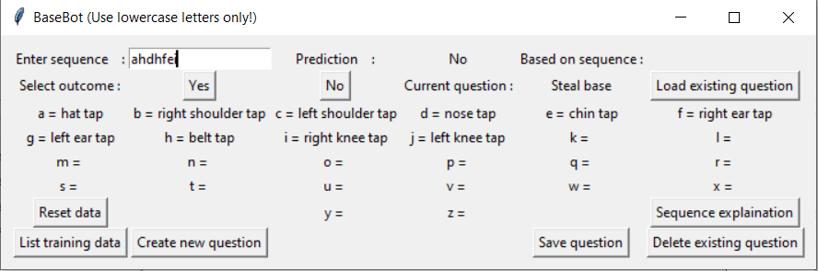
After clicking “Yes” the BaseBot look something like this:

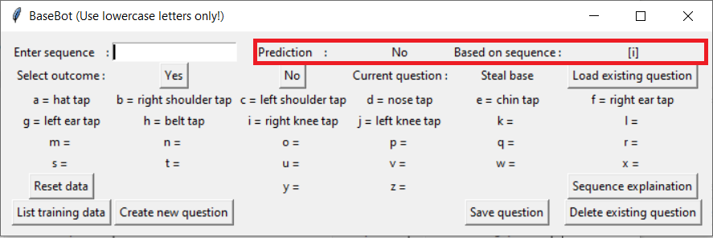
Notice the “Prediction” and “Based on sequence” fields when the condition listed in the based on sequence is satisfied the prediction switches to yes. Like below:

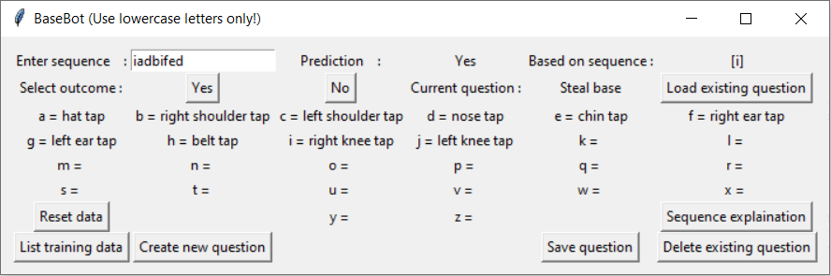
this outcome is going to be a no if you choose to click “List training data” in the bottom left corner you will be able to see all training data and the machine’s best hypothesises for what results in a yes out come after each new data point is submitted. Like so:
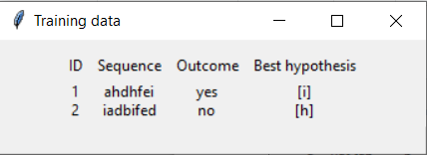

Over time the best hypothesis tends to identify itself.

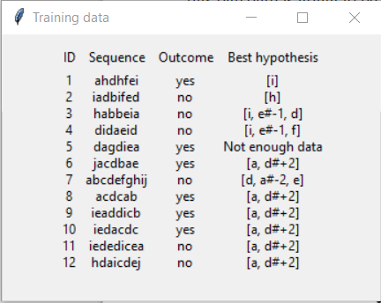

Looking at the events mapped to characters “a” and “d” events “hat tap” and “nose tap” are connected to a base runner stealing a base. But what does this set “[a, d#+2]” mean? If you use click the “Sequence explanation button” and the following:

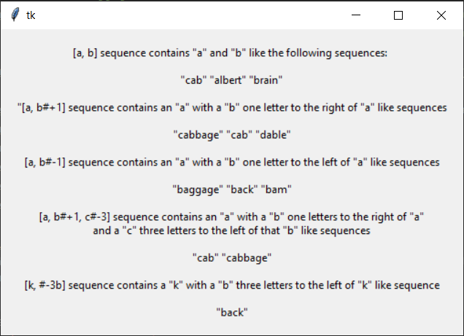

From this you can see that the signal to steal a base is “hat tap”, with “nose tap” that happens after the event after “hat tap”. You can save your data for a question if you have to gather more data later or reset your training data if you want to start over. You also have the option to delete question as well. You can also start training your data before you map your events. I hope that some people will find some use for this application. If nothing else it has been helpful to me in learning about one specific type of machine learning. The technical “under the hood” explanation behind how this works will be described in another document. I appreciate all feed back and suggestions.

